Chapter 19, Solution 26.

To get 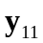 and 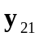, consider the circuit in Fig. (a).
2
1 
(a)
+
V₂ = 0
−
V₁
+
−
I₂
1
2 V_{x}
4 
2 
+
V_{x}
−
At node 1,
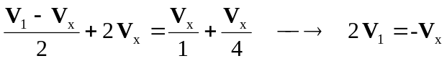 (1)

But 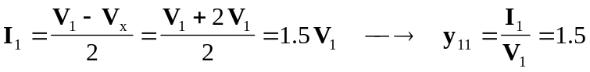

Also, 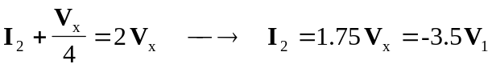
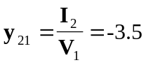

To get 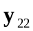 and 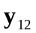, consider the circuit in Fig.(b).
2
1 
(b)
I₂
1
2 V_{x}
4 
2 
+
V_{x}
−
+
−
V₂
I₁

At node 2,
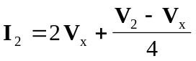 (2)

At node 1,
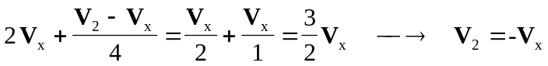 (3)

Substituting (3) into (2) gives
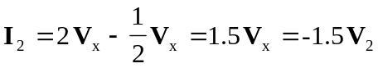
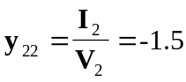

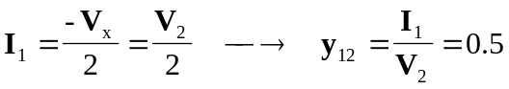

Thus,
